**On** **17th/09/2023**

***PROJECT NAME****:* **CHILD VACCINATION APPOINTMENT**

**UNIVERSITY OF RWANDA**

**NYARUGENGE CAMPUS**

**COLLEGE OF SCIENCE AND TECHNOLOGY**

**SCHOOL OF ICT**

**DEPARTMENT OF SOFTWARE AND COMPUTER ENGINEERING**

**WEB AND INTERNET TECHNOLOGY**

**NAME: MASENGESHO Odile**

**REG NBR: 222009783**

**YEAR OF STUDY: Year 2**

***TABLE OF CONTENTS***

CHAPTER 1 : ……………………………INTRODUCTION………………………………………………….

* 1. Historical background of the case study
  2. Explaining Problem
  3. Objectives of project

CHAPTER 2: ……………………..SYSTEM ANALYSIS AND DESIGN…………………………………

**2.1 System analysis**

2.1.1. Functional requirements of project

2.1.2. Intended users of project

2.1.3. Intended project partners

**2.2 System design**

2.2.1. UI design

2.2.2. Database design with ERD and relationship

CHAPTER 3 : ……………………IMPLEMENTATION……………………………………………………..

3.1. Introduction of the section

3.2. All screenshots with caption and discussion

CHAPTER 4 : ………………..CONCLUSION and RECOMMANDATION

4.1. Discussion of the implemented system

4.2 My recommandation

CHAPTER 1 : ……………………………INTRODUCTION………………………………………………….

* 1. **Historical background of the case study**

The idea of this project comes when I was home. One day I went to hospital at that time I was sick so I was looking for medicine but at that time I didn’t get what I was looking for. It takes me 2 days to get the medicine I directly thought about the mothers that comes looking for the vaccine and because of long line they spend a whole day there and never get the vaccine while they would rather stay home and come when there is not many people.

The mothers are the heart of the home when they are not around many things are not done properly and they have many responsibilities including : protecting their beloved ones and other chores at home.

That’s why I thought, if they get the appointment for their child it can help by reducing the wasting time and days and also it can help to protect the immunity of the young child by getting the right vaccine in the right time.

The best way the baby gets the vaccination at the proper time the best their future bright and that will benefits many oh no most of people around the world or in the country or family he/she is from.

This project will give the appointment to the mothers for their child telling them the time to get the vaccination and the time to get it and it will keep reminding them in case they are busy with their others responsibilities .

* 1. **Explaining Problem**

As we discussed above the problem this project come to solve is delaying of vaccination to the child and the wastage of time to the child’s mother while looking for the vaccination.

In Rwanda the public hospitals face the challenge of not enough number of nurses or doctors so that’s the cause of delaying of the service needed by people. In numbers the population of Rwanda is higher than the doctors and the nurse we have so it is not mostly possible to get the service in the way you wanted it to so in order to reduce that problem there need to be putted the system in which there is anumber of patieints that can be treated in a day depending on the doctors and the patients are available.

The problem of delaying of the service is faced by many and many people and it is kind worrying.

* 1. **Objectives of project**

The objective of the project are:

* Providing better service : by ensuring that the system is working properly and at the right time.
* Avoiding the wastage of time : to make sure that there is no one with appointment that did’t get the service to the time and date he/she was given.
* Protecting the child’s life : The child need vaccines and treatment in order to protect their immune system because their’s are not strong as thaaat of an adults, so getting the vaccines is the protection to his/her life.
* Avoiding the overtime to the doctors and nurses: doctors and nurses giving vaccines can work over time because of the number of people needing the service because of the love of their work, so this project will help them to know what number of people they have a day and know how to handle all of them properly.
* Satisfaction of every user: this project will do all it takes to fulfill the needs of every people using it and when there is a bad feedback will make sure to solve the problem faced in order to get satisfactory feedback.

“ My healthy child’s life my pleasure, leading to the bright future. ” //

MY SERVICE is a web based technology that brings up various vaccination site and hospital to work online by giving better service to peoples. Here the user(the people to get this service) provide personal details and vaccination information, because this vaccination are for child we suppose that their parents/ guardians are the one to give their child’s personal details and also put their email and contacts in order to communicate with them without any issue and to those with no smart phone we can also send a text message to inform them, once they register with those information , they registered users book vaccination for their loved ones by requiring the vaccination(first dose, second dose or third dose)depending on the range of ages.

After putting that they book an appointment after the vaccination site get the information and updates the status of appointment. The system will allow the registered user to download vaccination certificate.

CHAPTER 2: …………………….. SYSTEM ANALYSIS AND DESIGN…………………………………

**2.1 System analysis**

**2.1.1. Functional requirements of project**

**Project requirements**

|  |  |
| --- | --- |
| Project name | Child vaccination appointment |
| Language used | Html ,css ,javascript |
| database | mysql |
| User interface design | Html ,css ,javascript |
| Web browser | Internet explorer, google chrome |
| software | xammp |

MY SERVICE is a web based technology that brings up various vaccination site and hospital to work online by giving better service to peoples. Here the user(the people to get this service) provide personal details and vaccination information, because this vaccination are for child we suppose that their parents/ guardians are the one to give their child’s personal details and also put their email and contacts in order to communicate with them without any issue and to those with no smart phone we can also send a text message to inform them, once they register with those information , they registered users book vaccination for their loved ones by requiring the vaccination(first dose, second dose or third dose)depending on the range of ages.

After putting that they book an appointment after the vaccination site get the information and updates the status of appointment. The system will allow the registered user to download vaccination certificate.

**2.1.2. Intended users of project**

**In this website we have:**

* **Admin**
* **User**
* **Record manager**

1. **ADMIN**

Admin is the one to manage all features of the website and updates and upgrade the website for it to work effectively.

Admin can see all details like total vaccination center, total vaccination type, total vaccinator , new vaccination request and total vaccinated.

Admin also can manage the vaccination site by adding new or delete the one which does not give vaccine anymore.

1. **USER**

User can visit the application through a URL

**Dashboard:** user will have the dashboard where he/she will find the updates reminding him/her the date of appointment, and the vaccination type with their range in case he/she does not have information about it; user also will get the table containing vaccination appointment with their date if it is taken it will be shown on the column of the status whether it is taken, pending or not available.

**Vaccination submit form:** a user in this form will fill his first and last name and also range of age and the vaccination type for the appointment and also he will fill the date of birth day, month and a year in order to get clear information.

**Vaccination history:** if a user has the previous history of their child’s information it is required to be filled in order to give proper vaccination without causing any danger because of the unfilled information. Because this website is here in order to protect child not to make them suffer.

A user can also update his profile picture on his or her website ,change their password and recover their password.

1. **RECORD MANAGER**

**Dashboard:** the record manager will have the dashboard which contains the his/her profile, card that contain total number of the vaccinated child, total number of child that need the vaccination, and the list of child with appointment and the date of the appointment, and total vaccination received.

**Vaccination submit form:** the record manager can view the vaccination request and update the status according to the current status.

Record manager also can update his profile and reset password or recover the password.

**2.1.3. Intended project partners**

The partners of the project are:

-**RSSB (R**wanda **S**ocial **S**ecurity **B**oard**)**

**HERE ON BERIEF WE ARE GOING TO SEE WHAT YOU GET OPENING THIS WEBSITE**

1. ***LANDING PAGE***

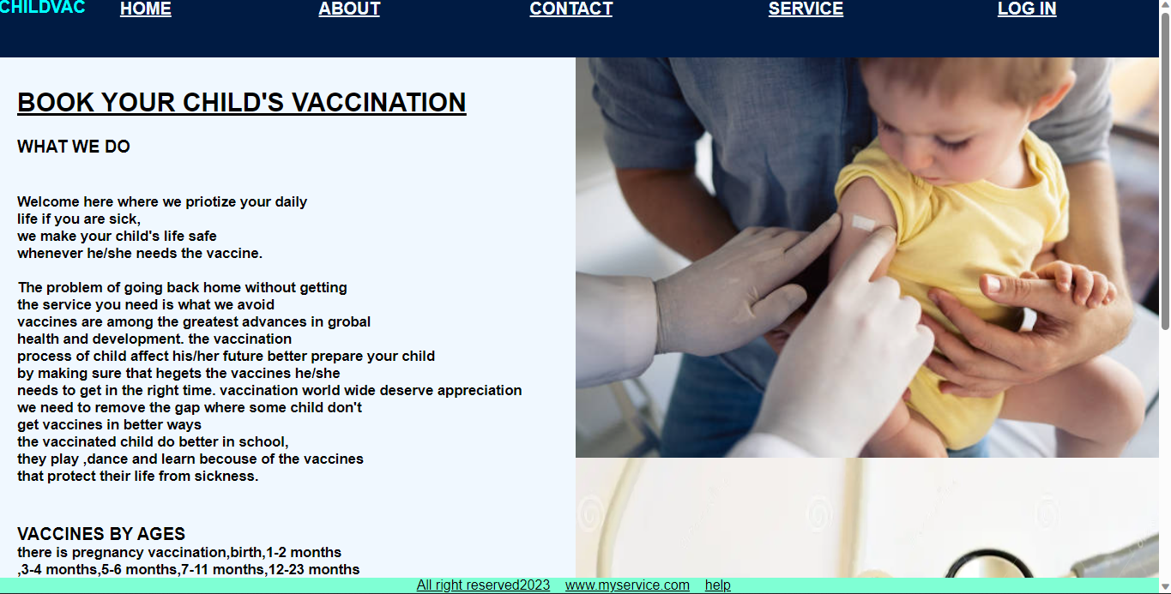

On the landing what you will directly see is the link above that make you access other information on it. It will also explain the main purpose of the website in order to get deep understanding about it. As you can see also the image shows the child getting the vaccination and under that there is another that contain syringe and vaccine type so this give understanding the importance and the problem solving of the website.

The purpose of this website is to give better service in better time without any delay and maintaining the better life of child which is also the development of the coming future as the youth is the power of the coming world. As a parent protecting the little ones of yours is the dignity of yours and also of a country.

1. ***HOME***

In the home link the content you get is same as the content found on the landing page guiding you according to where you want to go.

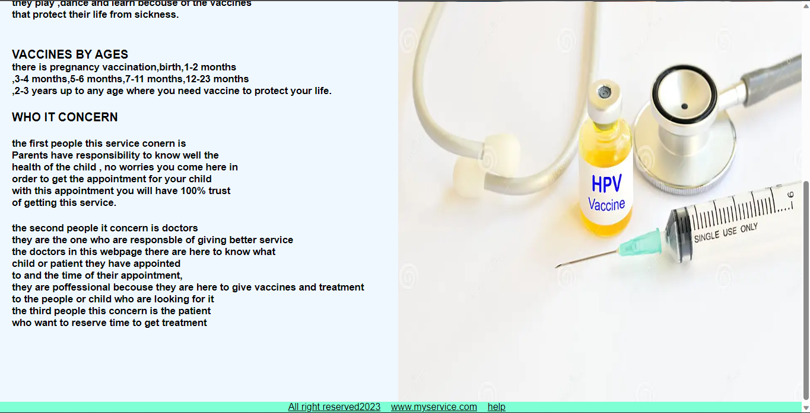

It will guide you telling you what to get and the range of the age and the type and dose to get for deep understanding.

1. **ABOUT**

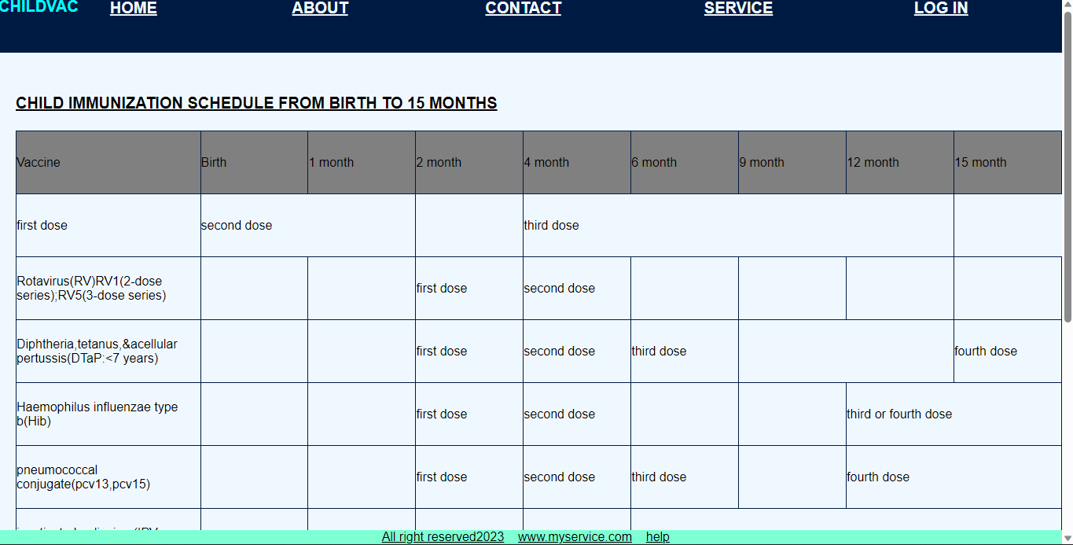

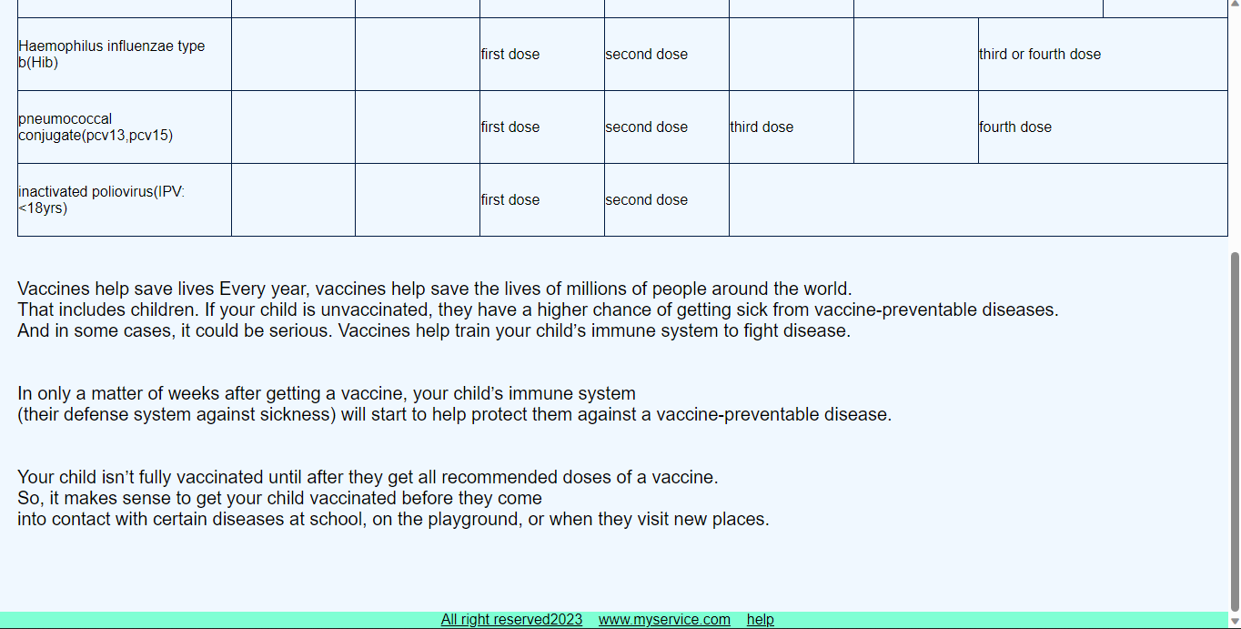

AFTER CLICKING TO THE ABOUT LINK IT WILL TELL YOU ABOUT THE VACCINATION